Ridhwaan Ali

M7: Assessment - Authentication

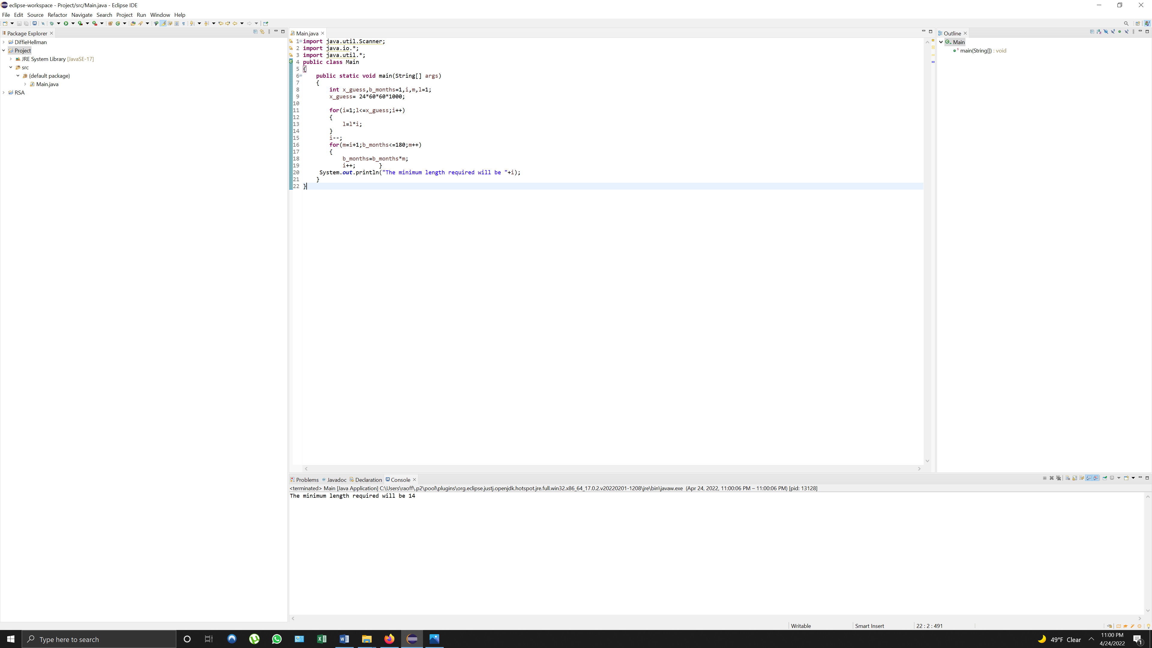

My result is minimum length 14. I got 14 by simply: first calculating the amount of guesses in one day (x_guess= 24(hrs)*60 (mins)*60 (secs)*1000(guesses per sec)), the length (l) arrangements correlate with the guesses and the loop will continue to run until the length is less than or equal to the guesses value, next the length required for the span of 6 months (180 days) this requires to multiply the next numbers and checking if it falls below 180. After that calculation the final result it 14.